
Logo
Name of the Institution

OUTCOME BASED EDUCATION
(OBE) MANUAL
DRAFT 1

ACADEMIC YEAR
2021 – 22

Team OBE

Foreword

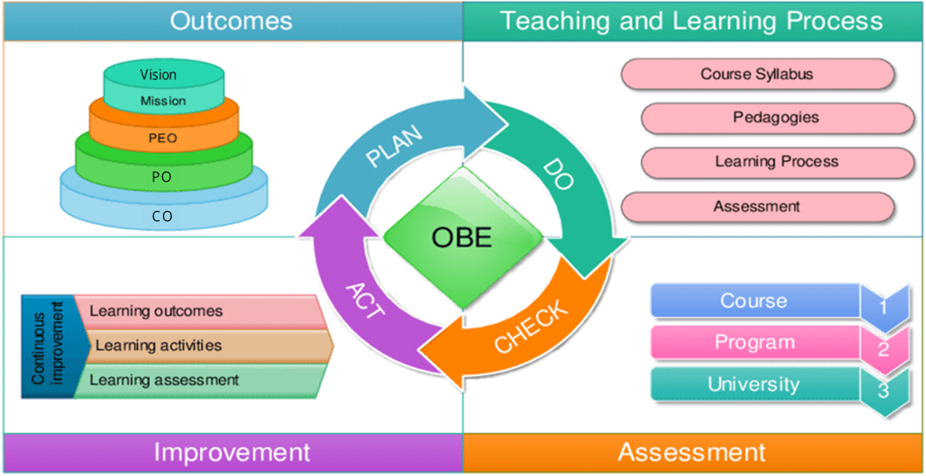

INDEX

1 | Introduction, Rational, what is OBE?............................ | 3
2 | OBE Architecture …………………………………….. | 5
3
4
5
6
7
8
9
10
11
12
13
14
15
16

Abbreviations:
OBE | Outcome Based Education | BTL | Blooms Taxonomy Level
HOT | Higher Order of Thinking | LOT | Lower Order of Thinking
PEO | Program Education Objective | PO | Program Outcome
CO | Course Outcome | PSO

Preamble

The rationale behind OBE

What is Outcome Based Education

Traditional Vs Outcome Based Education

Factors affecting the success of OBE

OBE ARCHITECTURE
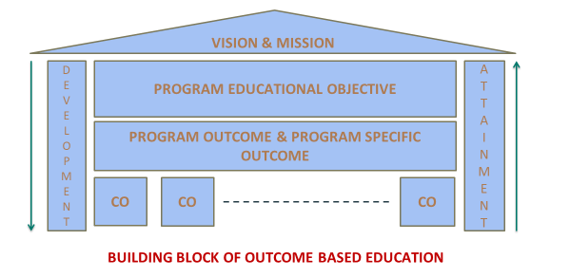

Vision of the Institution

Mission of the Institution | Values

Program Educational Objectives (PEO):
PEO 1
PEO 2
PEO 3

Program Outcomes (PO):
PO 1
PO 2
PO 3
PO 4
PO 5
PO 6
PO 7
PO 8
PO 9
PO 10
PO 11
PO 12

Before start of Semester | During the Semester | End of Semester
.

Details regarding the steps in developing a course using Outcome Based Approach

Structure of Course Outcome
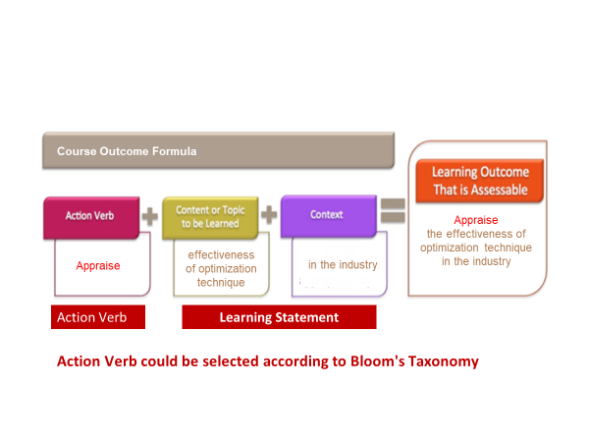
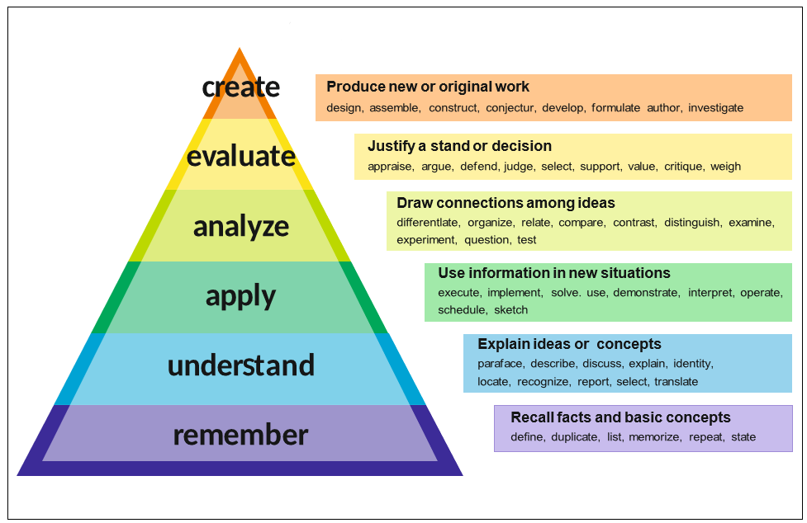
Bloom's Taxonomy: Action verbs for generating outcomes

Remembering | Understanding | Applying | Analyzing | Evaluating | Creating

While writing COs the following points should be addressed
Specific | Is there a description of precise behavior and the situation it will be performed in? Is it concrete, detailed, focused and defined?
Measurable | Can the performance of the outcome be observed and measured?
Achievable | With a reasonable number of efforts and application can the outcome be achieved? Are you attempting too much?
Relevant | Is the outcome important or worthwhile to the learner or stakeholder? Is it possible to achieve this outcome?
Time-Bound | Is there a time limit, rate, number, percentage or frequency clearly stated? When will this outcome be accomplished?

Outcome Based Assessment
The final assessment in an OBE approach is the estimation of the level of attainment of POs and PSOs. These outcomes are estimated from the estimates of all COs and Activity Outcomes AOs of the entire program. Hence every Course Outcomes (COs) and other Activity Outcomes (AOs) should be mapped onto the respective POs and PSOs in terms of the strength of mapping.
Mapping Scale for estimation of mapping strength (Sample)

Weightage | Relationship | % Attainment
0 | Nil | 0%
1 | Low | 1-50%
2 | Moderate | 51-70%
3 | Significant | 71-100%

CO – PO and CO – PSO mapping of a course.

 | PO1 | PO2 | PO3 | PO4 | … | PO11 | PO12 | PSO1 | PSO2 | PSO3 | PSO4
CO1 | 2 | - | 3 | - |  | 2 | - | 3 | 2 | - | 3
CO2
CO3
CO4
CO5

Non-Course Activity AO – PO mapping

 | PO1 | PO2 | PO3 | PO4 | … | PO11 | PO12
AO1 | 3 | 2 | 1 | - |  | 2 | 1
AO2
AO3
AO4

Program Matrix
Courses | P01 | P02 | ... | …. | P011 | P012 | PS01 |  | PS04
CO101.1 | 3 | 2 |  |  | 1 | 2 | 3 |  | 3
CO101.2 | 3 |  |  |  | -
CO101.3 | 2 |  |  |  | -
.
.
CO102.1 | 3 |  |  |  | 2
CO102.2 | 3 |  |  |  | 1
.
.
CO312.5 | 2 |  |  |  | 1

A course plan is a guided planning of the components of the course. This help in providing a check of various components in terms of the course outcomes. The cardinal principle behind the OBE process is constructive alignment.

Format of a Course Plan (Sample)

PMC2020 - OPERATIONS RESEARCH
Program and Semester: MCA, 3rd Semester

Course Outcome:
Upon completion of the course the students are able to:
CO1: Formulate OR Models of the real system from the verbal descriptions about the system.
CO2: Solve the OR models using appropriate algorithms and methods.
CO3: Analyze the solutions and propose recommendations to the decision makers
CO4: Use appropriate tools and resources that could be applied for the solution of problems.
CO5: Identify the problems and situations where the OR modeling could be effectively used

Module1

Course Outcome | Content/Syllabus | Learning Experience | Indicator/  Evaluation
CO1  CO2  CO3  CO5 | Linear programming problems-Mathematical formulation. Graphical, method of solution. Simplex method, Model Formulation. Definition of goal programming, Applications – graphical Solution. Ethical issues in optimization, modeling and decision making. | Students identifies the concepts related to various models. (Presentation, Video, Lecture)  Students formulate mathematical models in LPP (exercises and practice from Moodle task)  Illustrates the procedural steps in solution (Demonstrated lecture, videos and exercise)  Suggest on Ethical issues related to solutions (Discussion) | Chart of Models  Class Exercise  Active response sheet  Assignment  Project  Test1

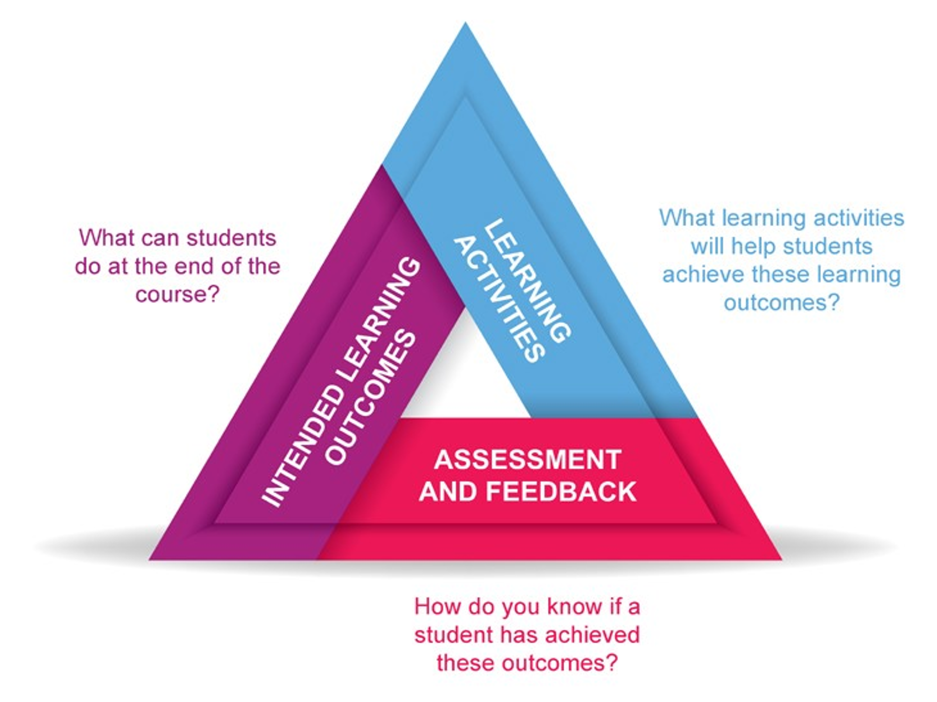
Constructive Alignment is the basic principle in OBE approach. Here the curriculum, teaching and learning activities and assessments are all directed towards the intended learning outcomes of the course. The emphasis of constructive alignment is on the learner. This approach places the students in the center of learning activity and teaching is considered as just a catalyst for learning. The teacher’s role here is to create an environment suitable for learning and get the students engage in learning activity. The figure shown here illustrates the constructive alignment.

Innovative practices that are integrated with OBE
- Small Group Discussion  - Problem based Learning  - Group Activities / Project work  - Assignments.  - Case Studies  - Concept mapping / mind mapping  - Tutorial worksheets  - Collaborative learning | - Inquiry – based Learning  - Simulation and Gaming  - Writing with peer review  - Debates and Discussions  - Random Calling  - Snow balling / syndicate groups  - Team based learning  - Buzz Groups

Outcome Based Assessment
Formative and Summative Assessments

Direct and Indirect Assessment

Design of a rubrics

Integration of rubrics with Outcome
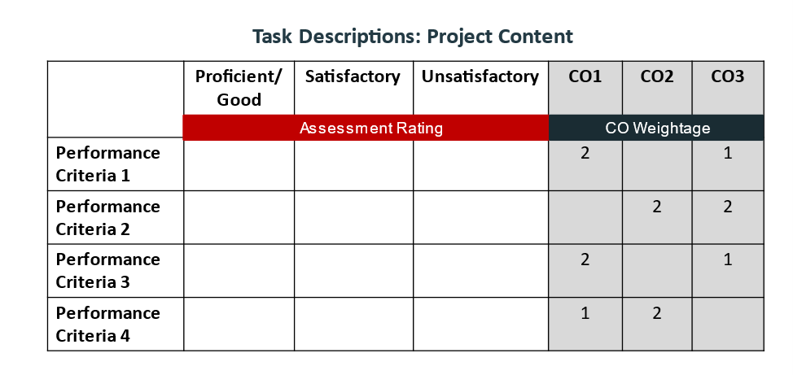

Integration of question paper with Outcomes
Sl No | Question | CO1 | CO2 | CO3 | CO4 | CO5
1 | Explain…… | 2
2 | Define……. |  | 1
3 | List the……. |  |  |  | 1
4
5
6
7
8
9
10
11
12
13
14
15
16
17
18
19
20

Estimation of COs: Detailed Procedure
Estimation of POs and PSOs: Detailed Procedure
Course Level Attainment: Detailed Procedure
Program Course Attainment: Detailed Procedure

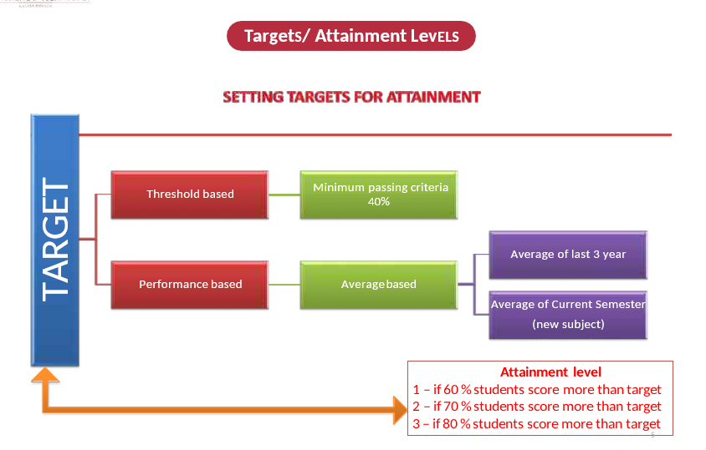

Illustration:
Course | Avg % result in last year | Clue for keeping target | Attainment 1 if | Attainment 2 if | Attainment 3 if
Course 1 | <40 % | Threshold | 40 % cross target | 50% cross target | 60% cross target
Course 2 | Above 40% but less than 50% | Threshold with high attainment level | 60 % cross target | 70% cross target | 80% cross target
Course 3 | Above 50 % | Average based | 40 % cross target | 50% cross target | 60% cross target
Course 4 | Above 80 % | Average based with high attainment level | 60 % cross target | 70% cross target | 80% cross target

Alumni Feedback:

Survey Format:

Strategies for Slow, Average and Advanced Learners:

Sample list of Activities:

Steps for Continuous Improvement:

